

Functional Design Document

IT20231208_001_HJ蘇州台版非書出口_SP修改

Version:

|  |  |
| --- | --- |
| Customer Name | IT |
| Document Author | *VickyLi* |
| Author’s Email / Phone | [*vickyli@eslite.com*](mailto:vickyli@eslite.com) |
| Creation Date | *2024/01/04* |
| Last Updated | *2024/01/04* |

|  |  |  |  |
| --- | --- | --- | --- |
| Document History | | | |
| Date | Version | Authors | Comments/Description of Change |
| *2024/01/04* | *1.0* | *VickyLi* | *Initial the document* |
|  |  |  |  |

**DOCUMENT CONTROL**

**UT Owners and Approvers:**

|  |  |  |  |
| --- | --- | --- | --- |
| Date | Name | Position | Signature |
|  | Vicky | Developer |  |
|  | Jacky | Develop leader |  |

**SIT Owners and Approvers:**

|  |  |  |  |
| --- | --- | --- | --- |
| Date | Name | Position | Signature |
|  | Leo | QC IT |  |
|  | Jacky | Develop leader |  |

**UAT Owners and Approvers:**

|  |  |  |  |
| --- | --- | --- | --- |
| Date | Name | Position | Signature |
|  | 王郁華 | User |  |
|  | Jacky | Develop leader |  |

**Golden Transaction Owners and Approvers:**

|  |  |  |  |
| --- | --- | --- | --- |
| Date | Name | Position | Signature |
|  | 王郁華 | User |  |
|  | Jacky | Develop leader |  |

**Go-Live Owners and Approvers:**

|  |  |  |  |
| --- | --- | --- | --- |
| Date | Name | Position | Signature |
|  | Ken | IT manager |  |

ECR sign off table:



**Document Version Numbering**

Document versions numbered ‘0.01, 0.02 etc’ are draft status and therefore can be changed without formal change control. Once a document has been formally approved and issued it is version numbered ‘Version 1.0’ and subsequent releases will be consecutively numbered, following formal change control. The version number appears in the footer of every page.

**Table Of Contents**

Part 1 – Purpose 4

Part 2 – Requirements 4

1.1 Request 4

1.2 Test Cases 8

1.3 Business Case 8

1.4 Boundaries and Constraints 8

Part 3 – Contacts (as appropriate) 8

# Part 1 – Purpose

蘇州台版非書出口的發貨帳EX08過帳單號錯誤修正。

# Part 2 – Requirements

## Request

現行蘇州台版非書出口F003的發貨帳未過帳至F002，經確認為w_xsod.order_number欄位值不正

確。該資料因於sp68進檔時載入w_xsod的order_number接口為eben3, **正確應改為eben2。**

■ 修改EDL_GATEWAY.IEXP的Eslite_Sap_Sp68_Imp_Fun, 建立Eslite_Sap_Sp68_Imp_Fun_20240104_vicky

測試

- 將insert iexp..w_xsod的order_number欄位的接口由eben3改為**eben2**

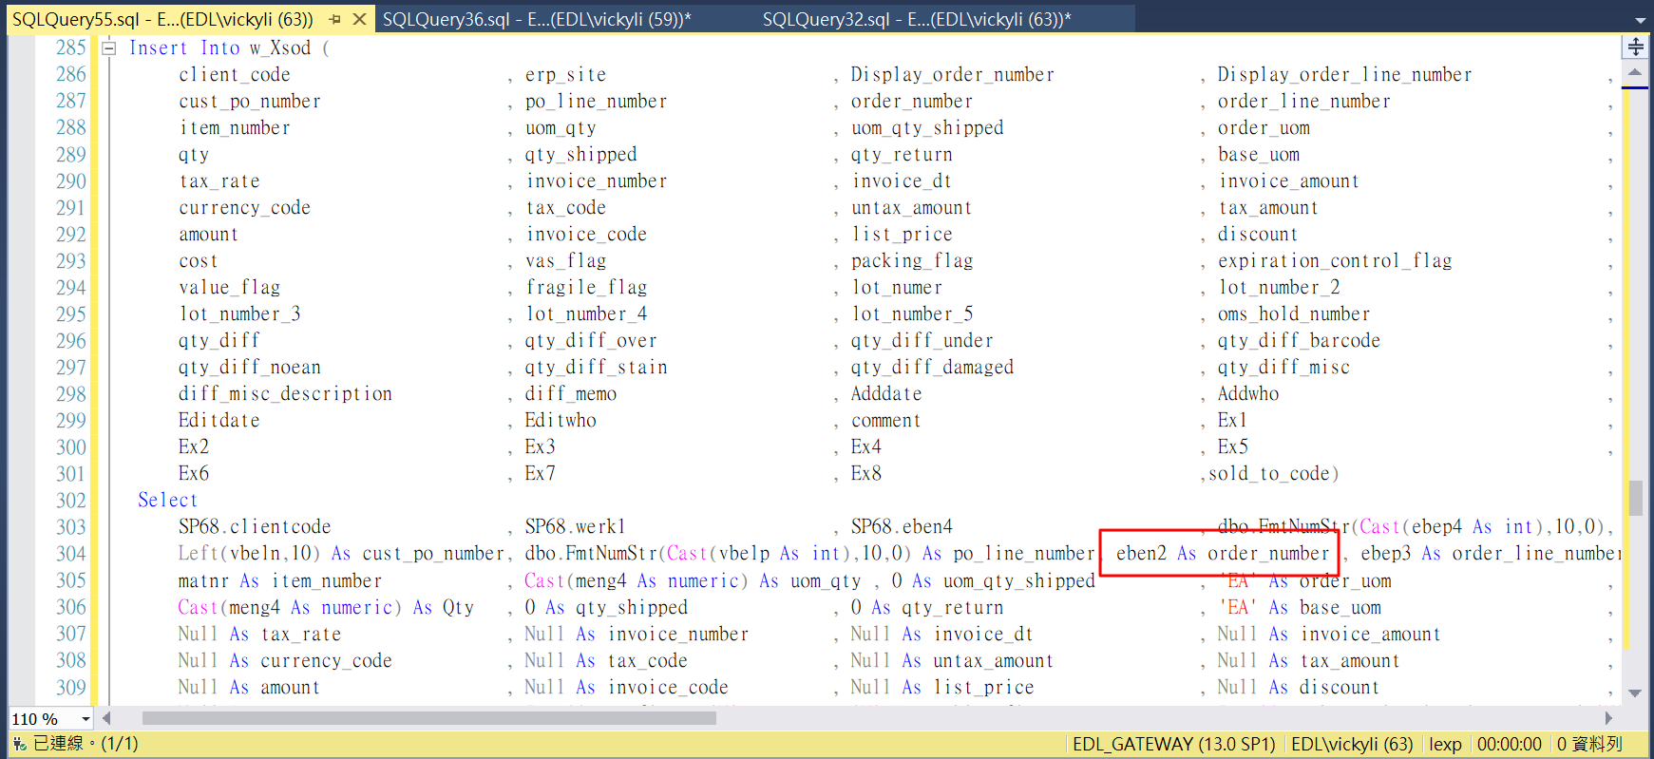

■ 修改EDL_GATEWAY.IEXP的_Edi_OutPut_Fmt, 建立_Edi_OutPut_Fmt_20240104_vicky測試

- 將非書與書以iexp..w_xsod的order_number欄位是否為空，來判斷是否為書(空)或非書(有資料)。

## Test Cases

***1.21 UT：***

***1、測試1: 從sp68進檔寫入sp68後，執行***

***Eslite_Sap_Sp68_Imp_Fun_20240104_vicky資料載入，確認w_xsod的order_number是否為sp68的eben2欄位***

**■ 從192.168.1.121(EDL_GatewayTest)測試(因無排程執行進檔，因此手動寫入該筆sp68資料)**

INSERT INTO [192.168.1.121].[Sapi].[dbo].[SP68]

SELECT * FROM SP68_BK

where eben3 like '9200001280%'

**■ 手動執行**Eslite_Sap_Sp68_Imp_Fun_20240104_vicky將資料寫入測試GW (w_po,w_pod,w_xso,w_xsod等)

exec Eslite_Sap_Sp68_Imp_Fun_20240104_vicky 'SP68' , 'SP68504082846020231229110031.PUB' , 'ESL' , 'D:\SJOB\IMP\SP68504082846020231229110031.PUB' , ''

**■檢查w_xsod的order_number是否是寫入sp68的eben2欄位: 是的，皆為9200001281**

**-Sp68**

SELECT * FROM SP68 where eben3 like '9200001280%'

**-W_xsod**

Select * from iexp.dbo.W_xsod with (nolock) where cust_po_number = '5040828460'

***2、測試2:測試回檔是否為正確欄位***

**■ 手動寫入w_case_s,w_cased_s, 以在測試區匯出回檔檔案**

INSERT INTO [192.168.1.121].[iexp].[dbo].[w_Case_S]

SELECT * FROM w_Case_S where shipment_id='CN-240001'

INSERT INTO [192.168.1.121].[iexp].[dbo].[w_Cased_S]

SELECT top 1000 * FROM w_Cased_S where po_number='5040828460'

**■ 手動執行產檔程式**

Select SJOB.dbo.XsdQueryExp('EX08_CASE','EX08_CN-240001.PUB','ESL,CN-

240001' ,'D:\SJOB\fmt\xsd\exp\SAP_EX08_CASE_Fmt_vicky.xsd' )

**■ 查看產出的檔案格式內容**

**已與靖苓提出的格式相符**

***1.22 SIT：***

***1.23 UAT:***

## Business Case

*Business justification must be supplied. Example business case reasons:*

1. *Customer requirement*
2. *Legal requirement*
3. *Expected savings - cost or FTE across a period of time (usually a year)*
4. *Other*

## Boundaries and Constraints

*Any business or technical limitations to be taken into consideration. Please include all customers, Exel sites or business units that will be affected by this modification.*

# Part 3 – Contacts (as appropriate)

|  |  |  |
| --- | --- | --- |
| Role | Name | Email |
| Developer-data source | EricChien | ericchien@eslite.com |
| Site Super User | 郭慶莊 | sallykuo@eslite.com |
| Requester | 趙秀娟 | shirleychao@eslite.com |